

Project report

Practical Project Management



Shukri Isse (N0813688)

Matthew Rose (N0815464)

Sami Ljimari (N0812237)

Aida Gliaudelyte (N0813320)

Tanmay Poddar (T0093879)

# Abstract

The Practical project management assignment is a group software development project, in which we as a group conceive, design and develop a software product. The group decided to create a responsive website, in which the website can be operated on all screen sizes such as smart phones, tablets or laptops.

The decision was made to create a blood donation website. The basic premise for the website is to allow the users to register and create an account where they can locate blood donation centres local to them, hospitals can find the required blood type and contact the user when the blood is required. When the user creates their account, the information of this user such as their name, DOB, sex, blood type and their contact information will be stored on a database.

The database will be accessed when either the user is trying to login or when the hospital is need of some blood, the hospitals will get admin rights so that they can contact the user and request for some blood. When logging in the HTML page calls a php page which connects to the database and checks to see if the email and passwords match an existing user in the database.

Contents

Abstract 3

Introduction 1

Aim 1

Objectives 2

Functional Requirements 2

Project Management 5

Team Members & Responsibilities 5

Source of Information, Resources Required 6

Risk Assessment 8

Professional, Social, Ethical and Legal Issues 10

Project Plan, Milestones, Effort & Timescale for Whole Project 11

Software Designs 13

Wireframes 13

Use case diagram 18

Class diagram 19

State diagram 20

State Diagram description 21

Entity Relationship diagram (ERD) 22

Entity Relationship diagram description 23

Bibliography 24

Appendices 26

Appendix 1 – Meeting minutes 26

Project Definition

# Introduction

Donating blood is a lifesaving act of kindness and in the year 2018, an estimate of 830,000 people gave blood in England (Mike Stredder, 2019). While most of the people who donated previous years will continue to donate, some donors will no longer be able to donate due to ill health, pregnancy or other circumstances. However, the registration of new donors will help replace those donors who will no longer be able to donate.

For this project, the group has decided to investigate and create an online blood bank management system to manage blood donation records across England. The online system will be used to store records such as registered donors, registered NHS hospitals/organisations and different blood groups.

Also, with this online management system, donors will be able to register to see if they meet the blood donation requirements; healthy, weigh between 50kg and 160kg are aged between 17 and 66. In England, men can donate blood every 12 weeks and women every 16 weeks, with our online system the donors can get updates on when they can donate again after the 12/16 weeks waiting period finishes (NHS, unknown).

The prime focus of this online system is keeping a record of blood groups so that hospitals/ organisations can request blood according to the availability of the blood group they need.

There are 4 main blood types: A, B, AB, and O. As shown on the chart on the left, blood types A positive(A+) and O positive(O+) is the most common blood types, this means these two blood types are more in demand. Also, blood type O negative(O-) is a universal blood type as it is safe for everyone to receive O negative(O-) blood cells, this means it would be beneficial to have more O negative blood (O-) donations (NHS, 2019).

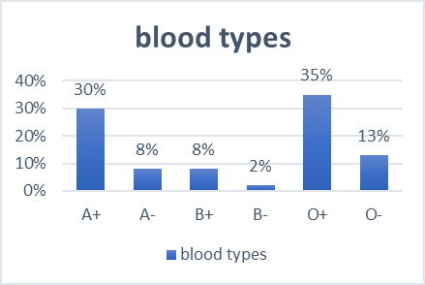

Figure 1. Blood Types

Currently, there are existing online systems that are like our blood bank system such as “American Red Cross”, “Welsh Blood Service” and “Vitalant”. This project relates to the NHS Blood and Transplant (NHSBT) organisation as they already have an existing website called “Give Blood”. Their online system is widely by hospitals all over England and they have a similar objective as our online blood bank system, however, in our system we plan to adapt from existing online systems to create an online system where both the NHS and private hospitals in England can request blood.

# Aim

The aim of this project is to create an online blood bank management system that simplifies the way organisations request blood and how donors register to donate blood. Moreover, the project aims to store and maintain records of every blood donation that happens through our online system.

# Objectives

* The system will be accessible on various browsers and screen sizes.
* An easy design that can be understood fast by new users.
* Organisation registration page.
* User registration or login page.
* Option for users to view records of their previous donation history.
* Update users when they can donate again.
* Blood donation appointment booking.
* User can view, cancel or change appointments.
* Users can view and update their personal details.
* To synchronise donor and bloodstock database
* Hospitals can view all records of donations they have received.

# Functional Requirements

The system must have a way to distinguish each user and his or her blood group and type. Furthermore, and maybe the most important requirement of all will be to check each patients’ blood for possible diseases or any other criteria which would affect his or her ability to donate their blood to others. Once the system has a way to check each user for their blood group, type and if the user is heathy it must reach the patient. In order to reach the patient, the system will have a “middleman” which will be the admin. The admin status will be given to hospitals and verified private sector doctors and facilities, to send blood requests on behalf of their patients or in a case of shortage. The login stage would prompt the donor for their national ID / passport details to create an account. At first the account would have a “un-verified” status and the donor would have to visit their local hospital or another trusted blood collecting facility in their location to get their blood tested and their blood group and type verified in order for the account to gain a “verified” status. Once an account gains the verified status, the user will be able to receive notifications for various types of blood donations if their account details match the request details. After a verified user accepts a request like this, he will be contacted by the facility and a time slot will be arranged to collect the requested amount of blood. Failure to attend the arranged collection time will result in a permanent ban as many blood requests do have an urgent status. Blood donation requests would have two types, first being an urgent request where the blood needs to be delivered as soon as possible, and in this case, users matching the request type would get a direct notification specifying any further details. The second type of request would be a blood storage shortage, which would appear on a dashboard to everyone. Because a storage shortage requires much higher amounts of donations, the dashboard would be used to encourage users to invite un-registered people to come to a facility, get checked and donate at will. The website should be overall very easy to use to any type of user and only have the most important information displayed with no adverts or other out of context information.

<https://www.blood.co.uk/>

The reviews for this website do not seem to be about the website itself, they all seem to be about the service that was provided by the staff. Therefore no one has suggested any improvements because they find it easy to navigate themselves around the site and its visually appealing. This website also gives you great facts such as which blood type is in demand and there is a little video about who will receive the blood. This is a great marketing tool, to try and increase the likelihood someone will register to donate as you are appealing to different sides of people.

# Project Management

Our group plans to mainly work with the use of workspaces and repositories like Trello and GitHub, where we will monitor our workflow, suggest useful edits to work which will get submitted and discuss any other necessary improvements through meetings and WhatsApp group. To combat low meetup attendance, we will make an attendance sheet for every meeting that will be held and monitor the attendance of every member, to further encourage attending group meetings each group member should present a demo of their work and their progress will be monitored as well. To combat low or no commitment from group members, we will set certain goals on our Trello workspace with deadlines on which the group will agree beforehand, and if a certain task is not finished until its deadline and the group member does not have any adequate reasoning for not completing the task on time, it will be monitored and if this behavior continues the tutor will be contacted. The group leader will be responsible for dividing work amongst the members and controlling the workflow and assessing the outcome of each member. If the work outputted by a member is deemed un-satisfactory, does not fulfill the requirements set by the group / assignment and if the member does not show any signs of willingness to improve their work through suggestions of the team further actions including contacting the tutor may be required. The only exceptions would be health issues / personal issues disabling a member from completing the agreed tasks, in which case the group would immediately contact the tutor / module leader for personal assistance with such issues or request a prolonged deadline date for project submission.

# Team Members & Responsibilities

|  |  |  |
| --- | --- | --- |
| Team Members | Primary Job Role | Secondary Job Role |
| Shukri Isse | Project Manager | Software Tester |
| Matthew Rose | Database Administrator | Project Manager |
| Aida Gliaudelyte | Software Architect | Software Developer |
| Sami Ljimari | Software Developer | Database Administrator |
| Tanmay Poddar | Software Tester | Software Architect |

The project manager is the person who overlooks the whole project, gives people deadlines and hands out the job roles to the group members. The project managers have the responsibility of planning and executing the project.

The database administrator will oversee designing and initialising the database, linking it up with the website to store all the customers personal and login information.

The software architect makes the design choices on the project based on their experience “and needs to interact with clients, product managers, and developers in order to envision, model and provide initial models and designs that can be built.” (Korkishko, 2017)

The software developer “also known as a computer programmer, you’ll be playing a key role in the design, installation, testing and maintenance of software systems.” (Unknown, 2019)

“A software tester is an individual that tests software for bugs, errors, defects or any problem that can affect the performance of computer software or an application” (Unknown, Unknown).

Each member has a primary role and a secondary role.

* Benefits:
  + Provide back up for issues or missing people
  + People excel in certain areas
  + Develop skills in other areas
  + Invites input from others therefore improves communication between everyone
  + Good time management skills to allow for both roles to be looked at and worked on
  + Better understanding of the project
  + The project manager can then ask for assistance or spread some workload if they need to and not feel so pressurised
* Side Effects
  + Your overall performance on the roles may suffer:
    - Less pressure as others working on same role
    - Less time to work on each activity
  + Some people may leave work to others therefore overloading people with too much work
  + Project time could increase as there will be more debates and discussions between the team
  + People may lose time explaining aspects about the project that their team member has already spoke about.

# Source of Information, Resources Required

Facts about blood donation

“In 2015, 1.1 million people in the UK donated blood – and more than 184,000 of them were first-time donors through the four blood services. In total, those donors helped blood services provide 1.89 million units of blood to hospitals, helping up to 5.7 million people.” (Microsoft reporter, 2016)

1. Someone needs blood every two seconds.
2. An average adult has between 4.7 and 5.0 Litres of blood in their body.
3. Around one in every seven people entering a hospital needs blood.
4. Our blood makes up around seven percent of our overall body weight.
5. O negative blood can be safely given to anyone, meaning it’s often the most requested by hospitals.
6. There is usually less than a week's supply of blood in the UK's blood banks at any one time.
7. Donated Red blood cells must be used within 42 days.
8. Donated Platelets must be used within five days.
9. Around one in four of us will need blood at some point in our lives.
10. One single donation can save the lives of up to three people.

(Benenden health, Unknown)

Hardware and Software Needed for website Identify where you will obtain these

* HTML - Hypertext markup language is the standard markup language for documents designed to be displayed in a web browser.
* CSS - Cascading Style Sheets is a style sheet language used for describing the presentation of a document written in a markup language like HTML.
* JavaScript - JavaScript, often abbreviated as JS, is a high-level, just-in-time compiled, multi-paradigm programming language that conforms to the ECMAScript specification.
* Oracle SQL database - Oracle Database is a proprietary multi-model database management system produced and marketed by Oracle Corporation.
* Visual Studio - Microsoft Visual Studio is an integrated development environment from Microsoft. It is used to develop computer programs, as well as websites, web apps, web services and mobile apps.
* NTU Udon server – The NTU webserver is software, or hardware dedicated to running said software, that can satisfy World Wide Web client requests.
* Computer/Laptop
* Monitor
* Mouse
* Keyboard

Addition aspects to the blood donor system

* Register to be a donor
* Contact Details
* Why Give Blood
* How Blood donations help
* Facts about blood donation
* NHS blood donation page on Facebook: <https://www.facebook.com/givebloodnhs/>
* Benefits of signing up for an online account
  + Find out where you can donate
  + Online booking system
  + View, change and cancel appointments
  + Update personal information
  + View your donation history

# Risk Assessment

|  |  |  |  |
| --- | --- | --- | --- |
| Risk | Likelihood | Impact | Measures to avoid or minimize the impact |
| Technical failure | Low | Losing the copy of completed work would have a serious impact on the assignment progress | The team must create a backup for offline versions at least every few days, that would help to avoid the risk. Furthermore, working on online collaboration platforms like google docs, that auto saves would help reduce risk even more. |
| Lack of participation due to illness or due to lack of interest | Medium | Lack of communication or attendance to the group meetings can have a negative impact on the team’s work. Attending group mates would have to complete more work in the same amount of time, possibly resulting in lower quality deliverables | The team should offer support to each other, make sure everyone is alright.  If the lack of participation is the result of illness, consider the severity of health problems. If a person is still able to deliver their part of work, provide he or she with detailed meeting summary, to get them up to speed and help them complete their part. If the health problem is severe, the rest of the group should ensure all required work will be completed by distributing job equally amongst themselves.    On the other hand, if the lack of participation is due to lack of interest and a person does not plan to change the approach, the team should inform tutor about the situation as soon as possible.  These measures would help to reduce the impact of lack of participation. |
| Group mates dropping out of university | Medium | This would leave group smaller in size and would have quite a significant impact on the progress of the assignment | The group should consider carefully the approach to the assignment in order to fully utilize every remaining person on the team to achieve the best result possible. If few of the groupmates drops out, the group should consider consulting with the tutor for any advice. |
| Not completing work on time | High | Would result in the caption of the final grade | It is the team’s responsibility to communicate and discuss the progress of the tasks and provide support to each other if needed. All necessary means of communication should be used in order to reach everyone to get any updates on the work. Would be a good idea to complete the tasks a few days before the actual deadline, to leave some time for editing and any changes if needed. |
| Issues developing the software | Medium | Would have a great impact on final grade and may result in a not fully functioning product. | Considering the development process, risks can arise with a lack of knowledge in software development tools or languages used. It is a must to help each other out. If faced with a problem, one should bring it up to the team’s attention and try to solve it together. In case more support is needed, communication with the relevant tutors should take place discussing all obstacles and getting more support. |
| Failure to make reasonable adjustments to avoid violation of existing legislations | Medium | Adverse impact on completing the aims of the system, since it would not be suitable for real hospital use | Carefully research and understand what requirements must be met in order to make the website fully functional and accessible for all member of public |

# Professional, Social, Ethical and Legal Issues

While developing Blood Donor System, a set of issues should be considered. It is important to get familiar with current legislations, codes of practice and codes of conduct in order to understand what issues can apply to project and how to mitigate them.

**Professional**

As it is stated in British Computer Society’s (BCS) code of practice, people working in computer related field should “comply with non-discriminatory legislation in the areas of race, colour, ethnic origin, sexual orientation, disability or age in all aspects of your work” (BSC,2004). In other words, when developing the Blood Donor System, the group should be careful not to violate the Equality Act 2010. The main objective of this act is to protect people from direct and indirect discrimination in society. The product should target all individuals of the public. However, the most pertaining aspect of Equality Act 2010 regarding the development of the system, would be to create the web site within accessibility guidelines, considering that Blood Donor System would be closely related to the public sector.

**Social**

There are risk and threats involved in the relationship between Computer technology and society, such as computer crime, privacy or security. BCS code of conduct states that professionals working in the computer related field must “have due regard for public […] privacy, security” (BSC,2015). Work should be done in the interest of the public, that is why it is at most importance to guarantee that acquired personal data from the trusting users will be protected. This can be done by creating a secure login to access personal data and automatic logoff function to ensure health records safety. Verification of identities, encryption of data and password policy, asking users to change login details on a regular basis could also be used to minimize the risk of data breach.

**Ethical**

Although the Blood Donor system would be beneficial and efficient for hospital use, users may not feel comfortable providing sensitive data and having it stored in a database without full explanation where and how the data would be used. The group should provide assurance to the members of the public that the system is developed in the best interest of the public and collect only necessary data. In consideration of user legitimate rights, the full disclosure about data collection and usage should be provided to third Parties and accepted by them before data submission with the opportunity to decide not to share personal data, resulting in declined participation in Blood Donor project.

**Legal**

There is a variety of legislations to be considered while developing new projects. The group should get familiar with the Data Protection Act 2018. This act controls how personal information acquired from the public is used by organisations, businesses or the government. Everyone who is dealing with sensitive personal data must make sure that information is accurate, is used for specified purposes and is managed in a secure manner. To follow the Data Protection Act 2018, the group should make it possible for users to update their personal data, secure the data provided by necessary security measures and limit, who can have access to that information in order to ensure that it is used for disclosed purposes only.

# Project Plan, Milestones, Effort & Timescale for Whole Project

The First task in creating a functional blood donor website is to design all aspects of the system. Before development can get underway, we have to design the front end of the website as this will be what the users will see. We as a group have to take in many considerations for the design, for example:

* Professional (purpose of the site), colour co-ordinated, responsiveness (Should the website be accessible through mobile phones?) and examples of other blood donation websites.
* Following the website design, we also have to design the database to ensure we hold all the relevant information required for example when the user is registering, we will need their name, age and blood type. How often will the database be used as the more the database is used the higher chance of the data becoming corrupted or faulty.

The purpose of this stage is to be able to visualise what the final product will look like and how it should perform. Designing the website benefits the development stage of the project as you will spend less time in the future trying to move bits around for the most aesthetically pleasing appearance.

Development – Following the designing of our blood donation website comes the development of it and this starts with the HTML code.

* “HTML (HyperText Markup Language) and is the most basic building block of the Web. It defines the meaning and structure of web content.” (by MDN contributors, 2019) The HTML is the code used to see what content is put on the page, from headers, to pictures or videos.
* “CSS (Cascading Style Sheets) allows you to create great-looking web pages” (by MDN contributors, 2019). You will not be able to make your website look professional and aesthetically pleasing through just the use of HTML. CSS allows you to add colour, change the layout and gives the website some characteristics.
* “JavaScript is a scripting or programming language that allows you to implement complex features on web pages” (by MDN contributors, 2020). We could use JavaScript to give the website more features such as a slide show or a menu-toggle button. JavaScript is used when you want the page to do more than just sit there.
* “SQL (Structured Query Language) is a standardized programming language that's used to manage relational databases and perform various operations on the data in them.” (Sirkin, 2016) We will have to link both the HTML with the SQL database for us to be able to input the user information from the website into the database and then retrieve it when is needed.

Succeeding the Development phase of the project comes the testing. This stage is making sure that the software works and functions as expected. The testing would be completed on both the use of the website and database and how they merge together to make a fully functional system. This stage is very crucial to the final project as any improvements that need to be made can be written down and the project can then be sent back to the development stage for adjustments.

Everything that has happened so far on the project will all need to be written down in a report, stating anything that has gone well for the group and if there were any areas in which we got stuck on resulting in any time lost in subsequent sections of the Gantt chart and if we were to complete the same or similar group project again what would we change and why.

Gantt Chart-

# Software Designs

### Wireframes

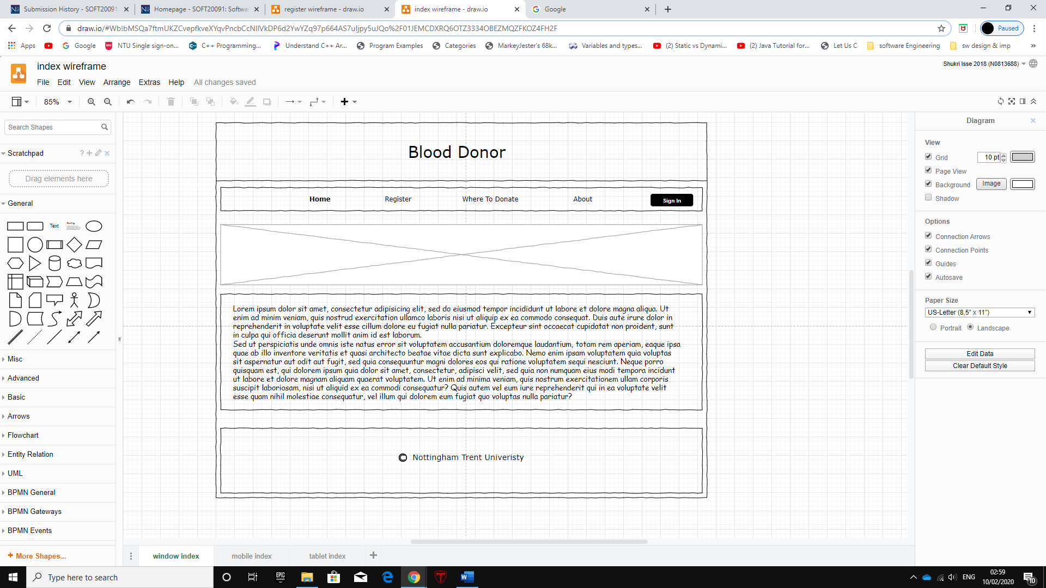**Home page wireframe:**

The above diagram is for the “home page” which is the first page the user will see when they open the online blood donation system. The home page sets the main structure for the whole system and this structure will be applied to all other pages, the main structure consists of a header with title, a horizontal navigation bar with links and a sign-up button and lastly a footer with copyrights.

There is also, a slider on the home page that will have series of images which are links to further information regarding blood donation. The main content for the homepage is after the slider and it will have information and statistics about blood donation and how it can help save a life.

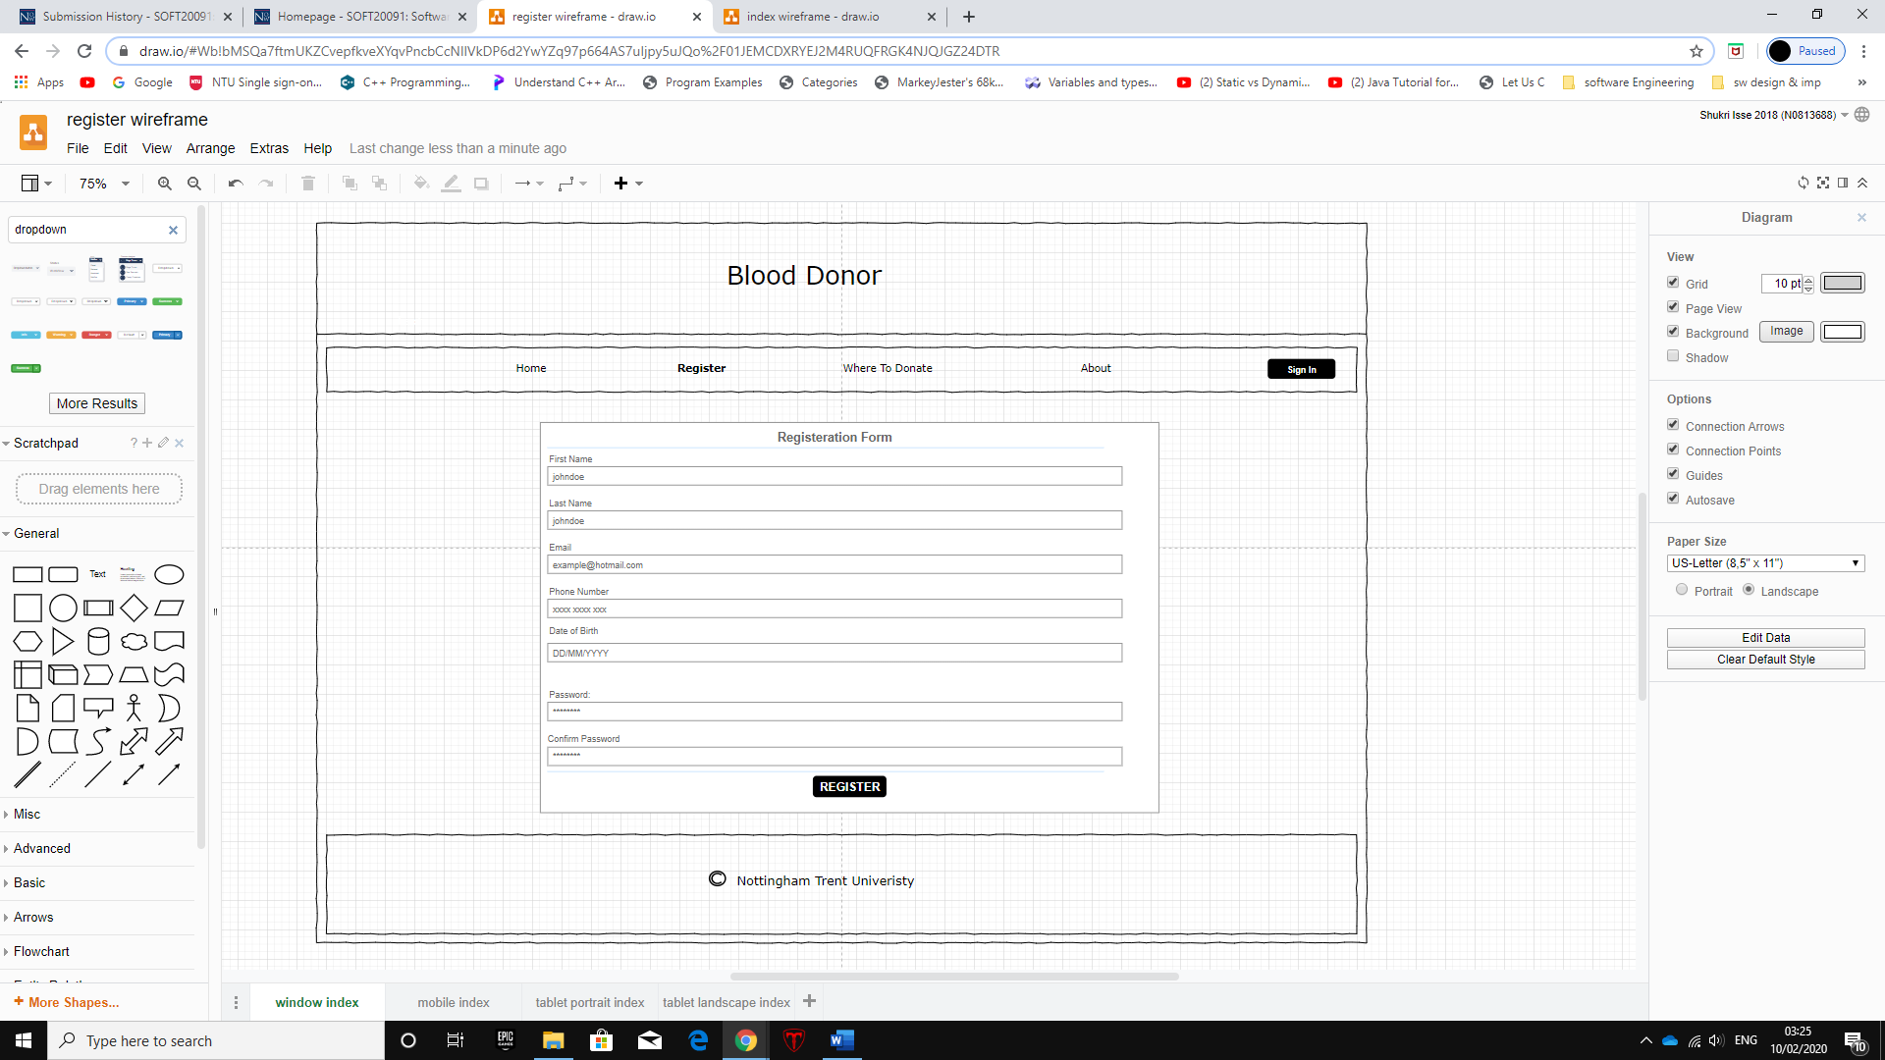**Registration page wireframe:**

This wireframe is for the “register” page which is the page for users to register if they want to create an account to donate blood. When the registration page loads a form is displayed that has fields for the user to fill in using their details such as; first name, last name, email, phone number and create a password. Once the user enters all correct personal details, they can press the register button to register and this will generate an automatic reference number.

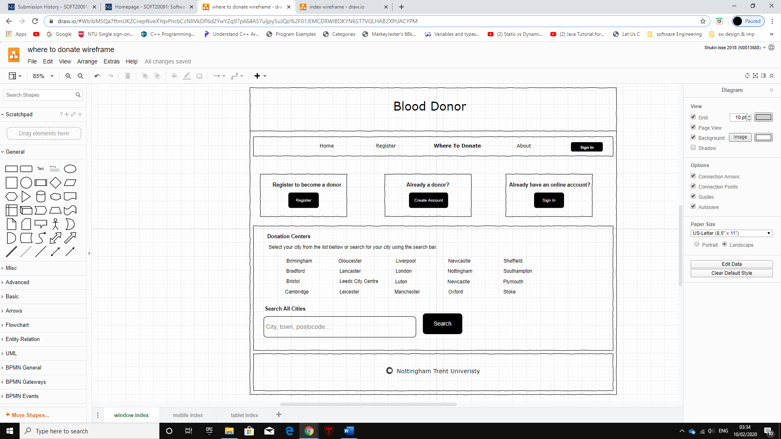**Where to donate page wireframe:**

The above diagram is for the “where to donate” page and it also has the same main structure as the home page. This page has three boxes displayed at the top of the page which the user can either register if they haven’t, create an account if they already are a donor or sign in if they already have an online account. Below those 3 option boxes there is a link list of main cities that have blood donation centres. Moreover, if the user’s city is not listed then they can use the search bar below to search for their city to see if there is a blood donation centre nearest to them.

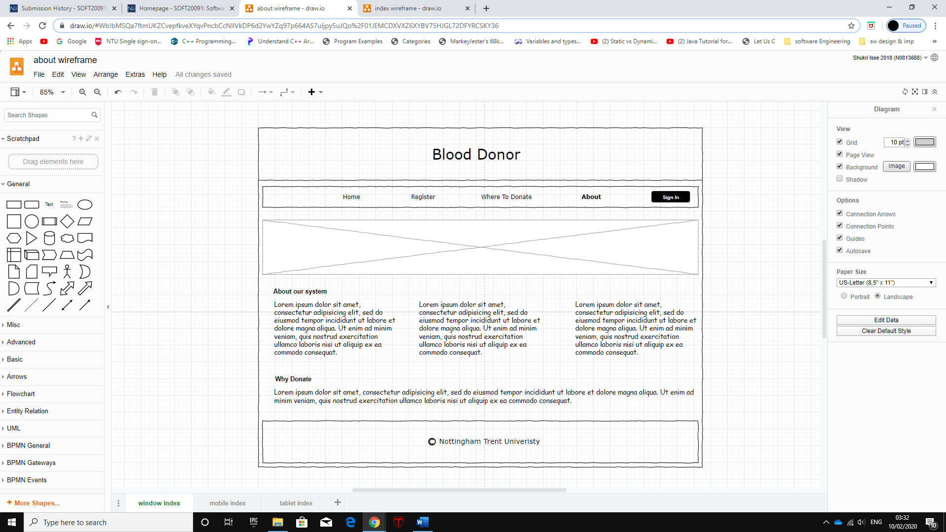**About page wireframe:**

The above diagram is the wireframe for the “about” page and it also has the same page structure as the home page. The “about” page will have information about our online blood donation system and how to use the system. This page has a banner to display latest news titles and paragraph structured information.

## Use case diagram

The use case diagram represents user interaction with the system. Private users can access multiple options once the website has been opened. The user can navigate through pages to get more information, search for specific details using keywords, register to be blood donor, log into account if it’s already created or reset password. Once logged in user can change personal details, deactivate the account, receive blood request or log out. Another actor in the use case diagram is Database Admin. This actor has access to user accounts and can help reset passwords or deactivate accounts. Hospital personnel is the last actor. They can request specific blood type and send out that request to the applicable blood donors.

## A screenshot of a cell phone Description automatically generatedClass diagram

## State diagram

This is the initial state, it is where the program begins. As you can see the this begins when the website will be opened.

The navigation bar will allow for users to easily find things throughout the website

The database will be used as a back end to keep all the user’s details. These details will be accessed for bits like logging in and contact details.

### State Diagram description

The state diagram is used to represent the behaviour of our website, how you can get around the website using the main areas such as the registering, navigation bar, search bar etc.

When you open up the website you can go to the navigation bar to register, once you register you will receive a reference number which will be stored under your details in the database. The database will be accessed when you go to log in, it will be accessed to make sure you already have an account and your log in details are correct. Once you are logged in you will be able to see all of the local donors and their contact details. Companies and hospitals will be able to access your details to notify you that a donation is needed, or a match has occurred.

## A screenshot of a cell phone Description automatically generatedEntity Relationship diagram (ERD)

### Entity Relationship diagram description

The ERD diagram shown, represents all the main features and functions of our blood donor website. It shows both, Primary keys (PK) and Foreign keys (FK) in the respectable tables. “Home page” is used to navigate the user to either login into their account using the “Login” table or to register with their information in the “Register” table. Further information and contact details are available at the Home page footer.

The Register option has 3 options for account type: Admin, Organization and User. Admin account type is used to maintain the site and resolve issues, this account type can only be registered with a unique token. Organization and User account types on the other hand, can be freely created and once all necessary information is submitted the form will get forwarded for verification request.

Organization forms get verified by state officials and put into Organization database. And User forms get verified if the users attend a health check in the nearest allocated facility and pass the check, this grants an access token to complete the registration process. If an invalid token is submitted, user gets prompted about the token being invalid. Once a valid token is inputted into the verification form, the user is granted access to its account and dashboard where organization account types post requests for blood donations with respective information about blood type and donation facility / location.

The “Login” table has 3 account options and requires the user email and password. This information gets forwarded to the verification process as the account status can change if a user does not attend a scheduled donation, which results in account restrictions / penalties.

# Bibliography

Benenden health, Unknown. *Benenden health.* [Online]   
Available at: <https://www.benenden.co.uk/be-healthy/body/blood-the-facts-of-the-matter/> [Accessed 9 January 2020].

Korkishko, I., 2017. *The role, skills, and duties of a software architect.* [Online]   
Available at: <https://syndicode.com/2017/10/24/the-role-skills-and-duties-of-a-software-architect/> [Accessed 9 Jan 2020].

Microsoft reporter, 2016. *The NHS needs 1.6m pints of blood every year – here’s how you can help.* [Online]   
Available at: <https://news.microsoft.com/en-gb/2016/08/16/microsoft-joins-campaign-to-find-200000-new-blood-donors-every-year/> [Accessed 9 January 2020].

Unknown, 2019. *SHARE Software developer job description.* [Online]   
Available at: <https://www.cwjobs.co.uk/advice/software-developer-job-description> [Accessed 9 January 2020].

Unknown, Unknown. *Software Tester.* [Online]   
Available at: <https://www.techopedia.com/definition/29845/software-tester> [Accessed 9 January 2020].

BCS, 2004. BCS Code of Practice. [Online]

Available at: <https://www.bcs.org/upload/pdf/cop.pdf>

[Accessed 9 January 2020].

BCS, 2015. BCS Code of Conduct. [Online]

Available at: <https://www.bcs.org/upload/pdf/conduct.pdf>

[Accessed 9 January 2020].

by MDN contributors, 2019. *HTML: Hypertext Markup Language.* [Online]   
Available at: <https://developer.mozilla.org/en-US/docs/Web/HTML> [Accessed 11 January 2020].

by MDN contributors, 2019. *What is CSS?.* [Online]   
Available at: <https://developer.mozilla.org/en-US/docs/Learn/CSS/First_steps/What_is_CSS> [Accessed 11 January 2020].

by MDN contributors, 2020. *What is JavaScript?.* [Online]   
Available at: <https://developer.mozilla.org/en-US/docs/Learn/JavaScript/First_steps/What_is_JavaScript> [Accessed 11 January 2020].

Sirkin, J., 2016. *SQL (Structured Query Language).* [Online]   
Available at: <https://searchsqlserver.techtarget.com/definition/SQL> [Accessed 11 January 2020].

*Call for more men to give blood as new figures show twice as many women as men became New Year donors* 2019. [online]. . Available at: <https://www.blood.co.uk/news-and-campaigns/news-and-statements/call-for-more-men-to-give-blood-as-new-figures-show-twice-as-many-women-as-men-became-new-year-donors/> [Accessed 1 January 2020].

NHS, *Who can give blood* [online]. . Available at: <https://www.blood.co.uk/who-can-give-blood/> [Accessed 1 January 2020].

NHS, 2019. *Blood types* [online]. . Available at: <https://www.blood.co.uk/why-give-blood/blood-types/> [Accessed 3 January 2020].

# Appendices

## Appendix 1 – Meeting minutes

|  |  |  |  |  |
| --- | --- | --- | --- | --- |
| **Meeting 1** | | | | |
| **Date:** Monday 9th December 2019 | | **Duration:** 1hour | | **Location:** Library |
| **Attendance:** | Aida, Matthew, Sami, Shukri | | | |
| **Overview:** | | | | |
| The first part of this meeting consisted of brainstorming ideas and deciding what system we would create for our project. After discussing ideas, we decided to create an online blood donation system. The second half of the meeting was spent defining aims, objectives and functional requirements of our project. The meeting ended with distributing tasks for the project definition document to work on over the Christmas holiday. | | | | |
| **Tasks given out:** | | | | |
| Introduction  Aims & Objectives | | | Shukri | |
| Functional requirements  Project management | | | Sami | |
| Team Members & Responsibilities  Sources of information, resources required | | | Matthew | |
| Risk Assessment  Professional, social, ethical and legal issues | | | Aida | |
| Project Plan, milestones, effort & timescale for whole project | | | Tanmay | |

|  |  |  |  |  |
| --- | --- | --- | --- | --- |
| **Meeting 2** | | | | |
| **Date:** Monday 20th January 2020 | | **Duration:** 1hour | | **Location:** Library |
| **Attendance:** | Aida, Matthew, Sami, Shukri | | | |
| **Overview:** | | | | |
| Discussing pages that our website should include and main design of website. The second part of the meeting was on discussing details of how the system would be operated. e.g. what information is needed to register and how hospitals would register and communicate with other hospitals to request blood. | | | | |
| **Tasks given out:** | | | | |
| Research other systems and come up with more ideas of how to develop an efficient online system. | | | All | |

|  |  |  |  |  |
| --- | --- | --- | --- | --- |
| **Meeting 3** | | | | |
| **Date:** Monday 27th January 2020 | | **Duration:** 1hour | | **Location:** Library |
| **Attendance:** | Aida, Matthew, Sami, Shukri | | | |
| **Overview:** | | | | |
| The main topic of this meeting was on system design such as use cases, database design, wireframes, class diagram and state diagram. The meeting also included discussing ideas that were researched the week prior to this meeting. | | | | |
| **Tasks given out:** | | | | |
| ERD diagram + description | | | Sami | |
| Use case diagram + description | | | Aida | |
| Class diagram + description | | | Tanmay | |
| State diagram + description | | | Matthew | |
| Wireframe designs + description | | | Shukri | |

|  |  |  |  |  |
| --- | --- | --- | --- | --- |
| **Meeting 4** | | | | |
| **Date:** Monday 10th February 2020 | | **Duration:** 1hour | | **Location:** Library |
| **Attendance:** | Aida, Matthew, Sami, Shukri | | | |
| **Overview:** | | | | |
| This meeting was based developing the front end of the website using the diagram from the previous meeting. Also, the colour scheme that would best fit for a blood donation system was discussed. | | | | |
| **Tasks given out** | | | | |
| Continue working on the front end of the website and commit to GitHub. | | | All | |

|  |  |  |  |  |
| --- | --- | --- | --- | --- |
| **Meeting 5** | | | | |
| **Date:** Monday 24th February 2020 | | **Duration:** 1hour | | **Location:** Library |
| **Attendance:** | Aida, Matthew, Sami, Shukri | | | |
| **Overview:** | | | | |
| In this meeting we started working on the backend of the system e.g. connecting to a database and developing a registration and login forms. To wrap to wrap the meeting up, the content that should be included in the upcoming interim review report. | | | | |
| **Tasks given out:** | | | | |
| Continue developing both front and back end of the website | | | All | |